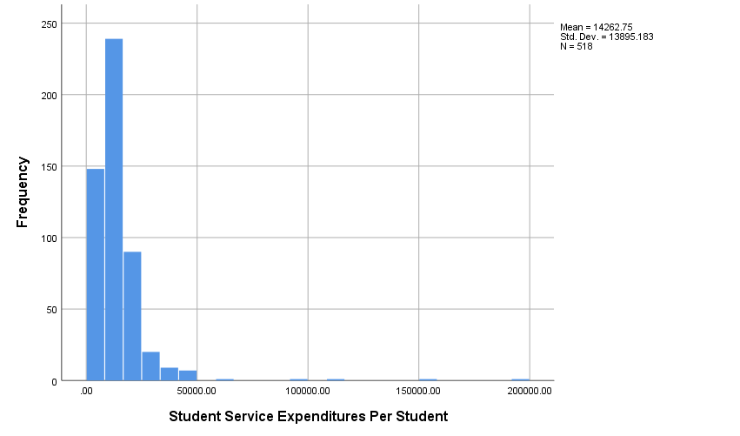

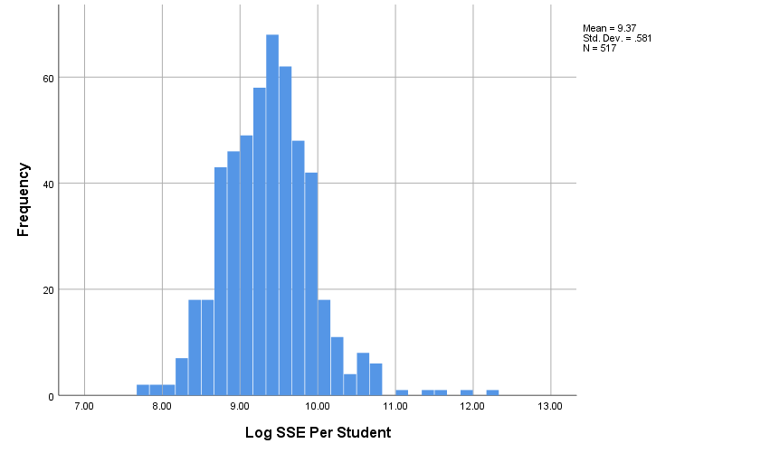

|  |  |  |  |  |  |  |
| --- | --- | --- | --- | --- | --- | --- |
| **Coefficientsa** | | | | | | |
| Model | | Unstandardized Coefficients | | Standardized Coefficients | t | Sig. |
| B | Std. Error | Beta |
| 1 | (Constant) | -7.915 | 4.623 |  | -1.712 | .088 |
| Log SSE Per Student | .747 | .503 | .062 | 1.486 | .138 |
| Percentage of Students Living On Campus | .115 | .011 | .458 | 10.757 | .000 |
| Bachelors_Dummy_Code | -.110 | 1.116 | -.004 | -.098 | .922 |
| Masters_Dummy_Code | 1.501 | .581 | .114 | 2.583 | .010 |
| Urban_Dummy_Code | .594 | .624 | .048 | .952 | .341 |
| Suburban_Dummy_Code | 1.506 | .754 | .095 | 1.997 | .046 |
| a. Dependent Variable: Number of Sexual Assaults per 1000 Students | | | | | | |

|  |  |  |  |  |  |
| --- | --- | --- | --- | --- | --- |
| **Degree_of_urbanization** | | | | | |
|  | | Frequency | Percent | Valid Percent | Cumulative Percent |
| Valid | Rural | 236 | 32.1 | 32.6 | 32.6 |
| Suburb | 150 | 20.4 | 20.7 | 53.3 |
| City | 338 | 45.9 | 46.7 | 100.0 |
| Total | 724 | 98.4 | 100.0 |  |
| Missing | -1 | 10 | 1.4 |  |  |
| System | 2 | .3 |  |  |
| Total | 12 | 1.6 |  |  |
| Total | | 736 | 100.0 |  |  |

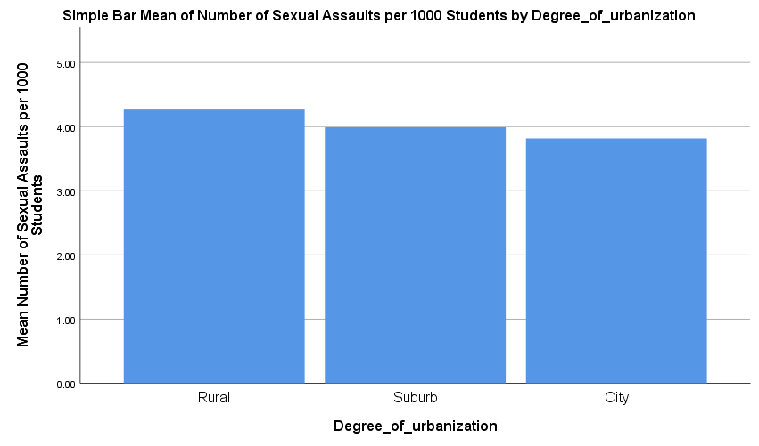

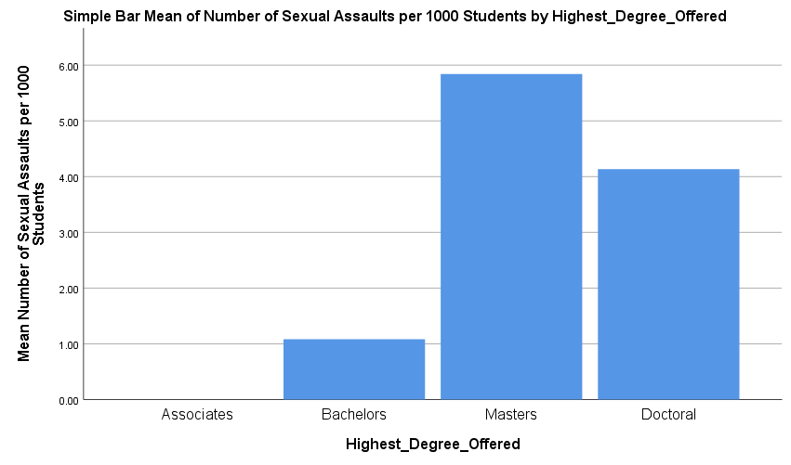

|  |  |  |  |  |  |
| --- | --- | --- | --- | --- | --- |
| **Degree_of_urbanization** | | | | | |
|  | | Frequency | Percent | Valid Percent | Cumulative Percent |
| Valid | Rural | 236 | 32.1 | 32.6 | 32.6 |
| Suburb | 150 | 20.4 | 20.7 | 53.3 |
| City | 338 | 45.9 | 46.7 | 100.0 |
| Total | 724 | 98.4 | 100.0 |  |
| Missing | -1 | 10 | 1.4 |  |  |
| System | 2 | .3 |  |  |
| Total | 12 | 1.6 |  |  |
| Total | | 736 | 100.0 |  |  |

|  |  |  |  |  |  |
| --- | --- | --- | --- | --- | --- |
| **Highest_Degree_Offered** | | | | | |
|  | | Frequency | Percent | Valid Percent | Cumulative Percent |
| Valid | Associates | 1 | .1 | .1 | .1 |
| Bachelors | 157 | 21.3 | 21.7 | 21.9 |
| Masters | 210 | 28.5 | 29.0 | 50.9 |
| Doctoral | 355 | 48.2 | 49.1 | 100.0 |
| Total | 723 | 98.2 | 100.0 |  |
| Missing | System | 13 | 1.8 |  |  |
| Total | | 736 | 100.0 |  |  |

|  |  |  |  |  |  |
| --- | --- | --- | --- | --- | --- |
| **Descriptive Statistics** | | | | | |
|  | N | Minimum | Maximum | Mean | Std. Deviation |
| Student Service Expenditures Per Student | 518 | .00 | 193828.26 | 14262.7451 | 13895.18300 |
| Number of Sexual Assaults per 1000 Students | 693 | .00 | 166.67 | 3.9483 | 8.34886 |
| Percentage of Students Living On Campus | 497 | .00 | 377.22 | 43.7276 | 24.48985 |
| EnrolledtotalADM2014_RV | 560 | 10 | 10835 | 1828.26 | 1713.774 |
| Valid N (listwise) | 470 |  |  |  |  |